Hulyanas Hill Information and Ordering System

A Web-Based Project
Presented to the
Faculty of Computer Studies and Information Technology
Southern Leyte State University

In Partial Fulfillment
of the Requirements for the Degree of
Bachelor of Science in Information Technology

David, Glia Mae R.
Proponent

Mr. Jeremiah Dela Cruz
Adviser

MAY 2026

INTRODUCTION
Background of the Study/Project
Technology has greatly changed how businesses operate, especially in the food industry, where customers now expect faster, more convenient, and more efficient services. Many restaurants have already adopted online systems to improve ordering processes, enhance customer experience, and reduce manual work. With the rise of digital solutions, businesses can streamline transactions, reduce human error, and provide better service to their customers.
However, some small establishments, such as Hulyanas Hill, still rely on manual or unorganized methods for handling orders and records. This traditional approach often leads to problems such as delayed service, incorrect orders, lost records, and difficulty in tracking transactions. Customers may also experience inconvenience when browsing menus and placing orders, while staff may struggle with managing updates and monitoring daily operations.
Because of these issues, there is a need for a more efficient and organized system. The Hulyanas Hill Information and Ordering System is proposed as a web-based solution that will modernize the ordering process. It aims to improve accuracy, speed, and overall service quality by providing a structured and automated platform for both customers and administrators.
Purpose of the System
The main purpose of the Hulyanas Hill Information and Ordering System is to provide a faster, easier, and more organized way of handling customer orders and business transactions. It is designed to replace manual processes with a digital platform that improves efficiency and accuracy in daily operations.
For customers, the system allows them to conveniently browse menu items, create accounts, place orders online, and track their transactions anytime. This removes the need for manual ordering methods and provides a smoother and more accessible ordering experience. It also ensures that customers have clear and updated information about available products.
For administrators, the system simplifies the management of menu items, customer information, and order monitoring. It reduces the workload involved in manual record-keeping and helps ensure that all transactions are properly recorded and organized. Overall, the system improves operational efficiency and supports better decision-making in managing the business.

Importance of the Project
The Hulyanas Hill Information and Ordering System is important because it improves the overall efficiency and reliability of restaurant operations. By shifting from manual processes to a web-based system, the business can reduce errors, improve transaction speed, and enhance customer satisfaction.
For customers, the system provides convenience by allowing them to easily browse menus, place orders, and track their purchases online. This helps save time and reduces confusion during transactions, especially when dealing with multiple orders or updates in the menu.
For administrators, the system is valuable because it organizes business operations in a more structured way. It helps manage orders, update menu items, and maintain customer records with less effort and fewer mistakes. Overall, the project supports better service delivery and improves the overall performance of the business.
Problems the System Aims to Solve
The Hulyanas Hill Information and Ordering System is designed to address several issues commonly found in manual ordering processes. One of the main problems is the delay in processing customer orders, which can negatively affect service speed and customer satisfaction. Manual systems also increase the risk of errors in recording orders, leading to incorrect or missing transactions.
Another issue is the difficulty customers face when browsing menu items and placing orders without a proper digital platform. Limited access to updated menu information can cause confusion and inconvenience. In addition, tracking orders and maintaining proper transaction records becomes challenging when everything is handled manually.
The system also solves problems related to unorganized records and inefficient administrative work. Staff often struggle with updating menu items, monitoring orders, and managing customer information efficiently. By introducing automation and a structured system, these problems can be reduced, resulting in smoother operations and better overall service quality.

OBJECTIVES OF THE SYSTEM
The general objective of the Hulyanas Hill Information and Ordering System is to design and develop a web-based ordering and management platform that improves the efficiency, accuracy, and convenience of food ordering and transaction processing at Hulyanas Hill. The system aims to provide a user-friendly interface for customers to easily browse menu items, place orders, and track transactions, while also giving administrators a reliable tool to manage menu items, monitor orders, and organize customer information. Overall, it seeks to modernize the restaurant’s operations by reducing manual processes and enhancing service delivery.
The system specifically aims to:
- Develop an easy-to-use online ordering platform that allows customers to register, log in securely, browse menu items, add products to their cart, and place orders smoothly.
- Provide customers with essential features such as order tracking, order history, and invoice generation for a more transparent and organized transaction experience.
- Create an efficient administrative system where administrators can add, update, and delete menu items, as well as monitor customer orders and manage user information effectively.
- Improve the overall speed, accuracy, and efficiency of service delivery at Hulyanas Hill by reducing manual work and enhancing both customer and administrative operations.

SCOPE AND LIMITATIONS
What the System Can Do
The Hulyanas Hill Information and Ordering System is a web-based platform that allows customers to conveniently browse menu items, add products to their cart, place orders, and track their transactions online. It also provides features such as order history, invoice generation, and user account management for a smoother and more organized ordering experience.
For administrators, the system enables efficient management of menu items, customer orders, and user accounts, as well as access to sales reports and performance analytics. Overall, the system improves the speed, accuracy, and organization of business operations at Hulyanas Hill.
Features Included
The system includes a comprehensive Admin Panel that allows administrators to manage the overall operations of Hulyanas Hill efficiently. Through this panel, the admin can add, update, delete, and view menu items to ensure that the available products are always up to date. It also provides full order management features, allowing administrators to monitor and update customer orders as needed. In addition, the admin can manage user accounts by editing or deleting customer information and controlling user permissions to ensure proper system access.
The admin dashboard also includes a reporting and analytics feature that displays important business insights such as total revenue, total orders, average order value, and number of customers. It also visualizes data through bar graphs showing daily revenue trends over time, as well as summaries of top categories and best-selling products. These features help administrators make informed decisions and better understand business performance.
On the User Panel, customers are provided with a personalized dashboard showing key information such as total orders, total spent, active orders, and recent transaction activity. Users can browse available menu items, add products to their cart, and proceed to checkout with ease. They can also remove items from their cart before completing a purchase, view their order history, and track the status of their current orders. The system also generates downloadable invoices for completed transactions.
Additionally, the user panel includes a profile management feature where customers can update their personal information and change their password securely. Overall, the system is designed to provide a smooth and convenient experience for both customers and administrators, ensuring efficient ordering, management, and transaction processing.
Limitations or Exclusions of the System
The Hulyanas Hill Information and Ordering System is designed to improve and digitize the ordering process at Hulyanas Hill; however, it still has certain limitations. The system is dependent on internet connectivity, meaning users may not be able to access its features when there is no stable internet connection. It is also a web-based platform only, so it does not function as a mobile application unless accessed through a browser.
In terms of functionality, the system is limited to ordering, menu management, and transaction processing. It does not include delivery tracking with real-time GPS integration or third-party delivery service integration. Payment processing may also be limited as it only implements cash on delivery as a payment method, as the system may not support full integration with all online payment gateways.
Additionally, the system excludes advanced enterprise-level features such as multi-branch management, automated stock/inventory tracking, and AI-based recommendation systems. It is primarily intended for managing the operations of Hulyanas Hill as a single establishment, focusing only on improving ordering efficiency, customer management, and basic sales reporting.

SYSTEM DESCRIPTION
Overview of the System
The Hulyanas Hill Information and Ordering System is a web-based platform designed to modernize and improve the ordering and management process of Hulyanas Hill. It replaces traditional manual ordering methods with a digital system that allows customers and administrators to interact more efficiently and accurately. The system focuses on improving convenience, reducing errors, and ensuring smoother transaction processing.
The system enables customers to access menu items online, place orders, and track their transactions in real time. At the same time, it provides administrators with tools to manage menu items, monitor orders, and oversee customer accounts. By centralizing these functions into one platform, the system improves overall operational efficiency and service quality.
Overall, the system is designed to provide a more organized and reliable ordering experience. It supports both customer-facing and administrative operations, ensuring that transactions are processed faster, more accurately, and with better record management.
Major Modules / Features
The Hulyanas Hill Information and Ordering System is composed of several interconnected modules that work together to ensure smooth, organized, and efficient operation of Hulyanas Hill. Each module is designed to handle a specific function within the system, supporting both customer and administrator needs.
The User Account Management Module is responsible for handling user registration, login, and secure authentication. It ensures that only registered users can access the system’s features. This module also allows users to manage their personal information, update their profiles, and change passwords securely, helping maintain account safety and data privacy.
The Menu Management Module provides functionality for displaying all available menu items to customers in an organized and user-friendly interface. For administrators, this module allows full control over menu content, including adding new items, updating existing product details, and deleting unavailable items. This ensures that the menu remains accurate, updated, and aligned with the actual offerings of the business.
The Cart Management Module enables customers to add selected menu items to their cart before finalizing their purchase. Users can review their selected items, adjust quantities, or remove items if they change their mind. This module ensures flexibility and convenience, allowing customers to modify their orders before proceeding to checkout.
The Order Processing Module handles the core transaction flow of the system. It manages the checkout process, order submission, and order confirmation. Once customers finalize their cart, this module processes the order details and records them in the system for further tracking and management.
The Order Tracking Module allows customers to monitor the status of their orders in real time. It provides updates such as pending, preparing, ready, or completed status, helping customers stay informed about their transactions. On the administrative side, it also helps staff update order progress efficiently to ensure accurate communication and service delivery.
The Order History and Invoice Module stores all completed transactions and allows customers to view their past orders at any time. It also generates downloadable invoices for each transaction, providing a clear record of purchases. This module supports transparency and helps users keep track of their spending history.
The Admin Management Module serves as the central control system for administrators. It allows them to monitor all customer orders, manage user accounts, and maintain overall system data. Through this module, administrators can ensure that all operations within the system are properly organized, updated, and functioning efficiently, contributing to better management of Hulyanas Hill.
User Roles and Functionalities
The system has two main user roles: customers (users) and administrators. Each role has specific functions designed to support their needs within the platform.
Customers are responsible for browsing menu items, adding products to their cart, placing orders, and tracking their transactions. They can also view their order history, download invoices, and manage their personal profiles by updating their information and passwords. This role is designed to provide a convenient and user-friendly ordering experience.
Administrators, on the other hand, have full control over the system’s operations. They can manage menu items by adding, updating, and deleting products, as well as monitor and update customer orders. Administrators can also manage user accounts, including editing or deleting customer profiles and controlling access permissions. In addition, they can view reports and analytics that help them understand business performance and make informed decisions for Hulyanas Hill.

TECHNOLOGIES USED
The Hulyanas Hill Information and Ordering System is built using modern web development technologies to ensure efficiency, reliability, and scalability for the operations of Hulyanas Hill. Each technology plays an important role in the development and functionality of the system.
Programming Language(s)
The system is primarily developed using PHP, which is responsible for handling the backend logic of the application. PHP is used to process user requests, manage data transactions, and communicate with the database. It allows the system to perform essential functions such as user authentication, order processing, and data management. On the frontend side, HTML, CSS, and JavaScript are used to structure the interface, design the layout, and add interactive features that improve user experience. HTML provides the structure of the web pages, CSS handles the visual design, while JavaScript adds dynamic behavior to the system.
Frameworks / Libraries
The system utilizes the Laravel Framework, which is a powerful PHP framework that simplifies web application development. Laravel provides built-in features such as routing, authentication, and database management, making the system more secure and organized. It also improves development speed and code structure through its MVC (Model-View-Controller) architecture.
In addition, Bootstrap or Tailwind CSS (if used in your project) is used for responsive design, ensuring that the system works well on different screen sizes such as desktops, tablets, and mobile devices. JavaScript libraries may also be used to enhance user interactions, improve UI responsiveness, and support real-time updates within the system.
Database Management System
The system uses MySQL as its database management system. MySQL is responsible for storing and organizing all system data, including user accounts, menu items, orders, and transaction records. It ensures that data is stored securely and can be retrieved efficiently whenever needed. Through structured tables and relationships, MySQL allows the system to manage large amounts of data in an organized and reliable way.

Development Tools Used
Several development tools are used to build and maintain the system. Visual Studio Code is used as the primary code editor for writing and managing the system’s source code. It provides helpful features such as syntax highlighting, extensions, and debugging tools that improve development efficiency.
XAMPP is used as a local development server, providing Apache and MySQL services for testing the system before deployment. It allows developers to run the system locally on a computer without requiring an internet connection. Additionally, Composer is used for managing Laravel dependencies, ensuring that all required packages and libraries are properly installed and updated. These tools together help ensure smooth development, testing, and deployment of the system.

SYSTEM DESIGN
Use Case Diagram
Figure 1 displays the Use Case Diagram for the Hulyanas Hill Ordering System, defining the software's functional scope through a dashed rectangular system boundary. The diagram separates system behavior into two distinct roles, linking the client-facing User actor to ten core shopping and account management functions. On the administrative side, it connects the admin actor to six back-end management capabilities, explicitly mapping out the operational permissions and responsibilities within the application.
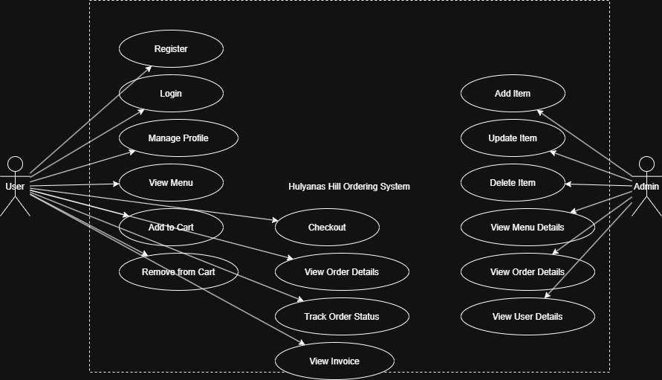

Figure 1: Use Case Diagram

Flowchart
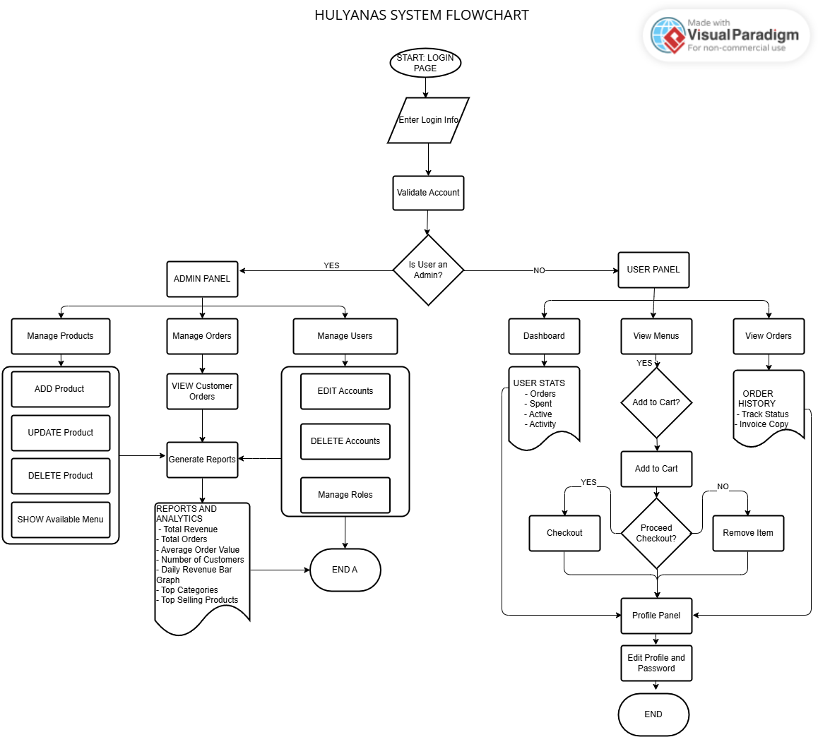
Figure 2 presents the Hulyanas System Flowchart, which details the operational flow of the system starting from account login and validation. Upon authentication, a central decision node routes users based on their access level, directing administrators to an Admin Panel focused on product, user, and order management with integrated analytics. Standard customers are routed to a User Panel that facilitates dashboard tracking, menu browsing with a checkout decision loop, and profile management before reaching the final system termination node.

Figure 2: Flowchart
ER Diagram
Figure 3 illustrates the database Entity-Relationship Diagram (ERD) for the ordering system, mapping out five core tables tailored for user management, product catalogs, shopping carts, and order fulfillment. The design outlines clear data attributes for each entity, capturing essential details like user roles, product pricing, cart quantities, and complete transactional metrics. Using standard crow's foot notation, the diagram establishes one-to-many relationships that seamlessly connect users to their carts and orders, while bridging products directly to finalized individual order items.
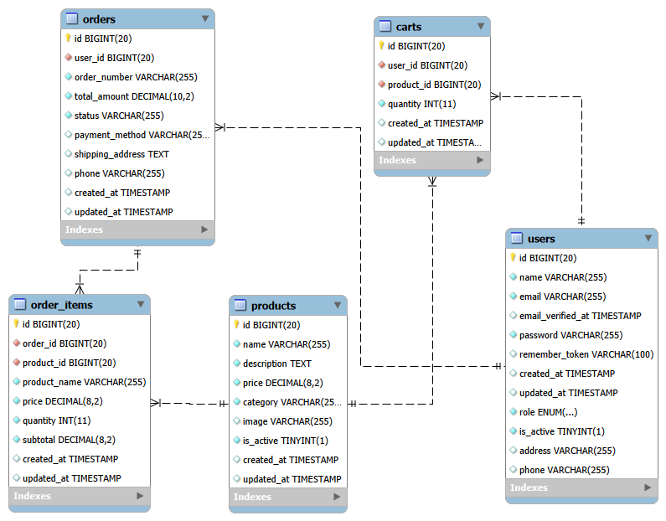

Figure 3: ER Diagram
System Architectural Diagram
Figure 4 presents the System Architectural Diagram for the platform, detailing a multi-tier web application architecture structured around the Laravel framework and a MySQL database. It illustrates the complete data lifecycle, showing how secure HTTPS requests from customer and administrator web browsers flow through layered presentation, application, and data access tiers. Finally, the diagram highlights the system's deployment environment and linear execution path, including how data is indexed on the database server and when external file storage services are triggered for invoice downloads.
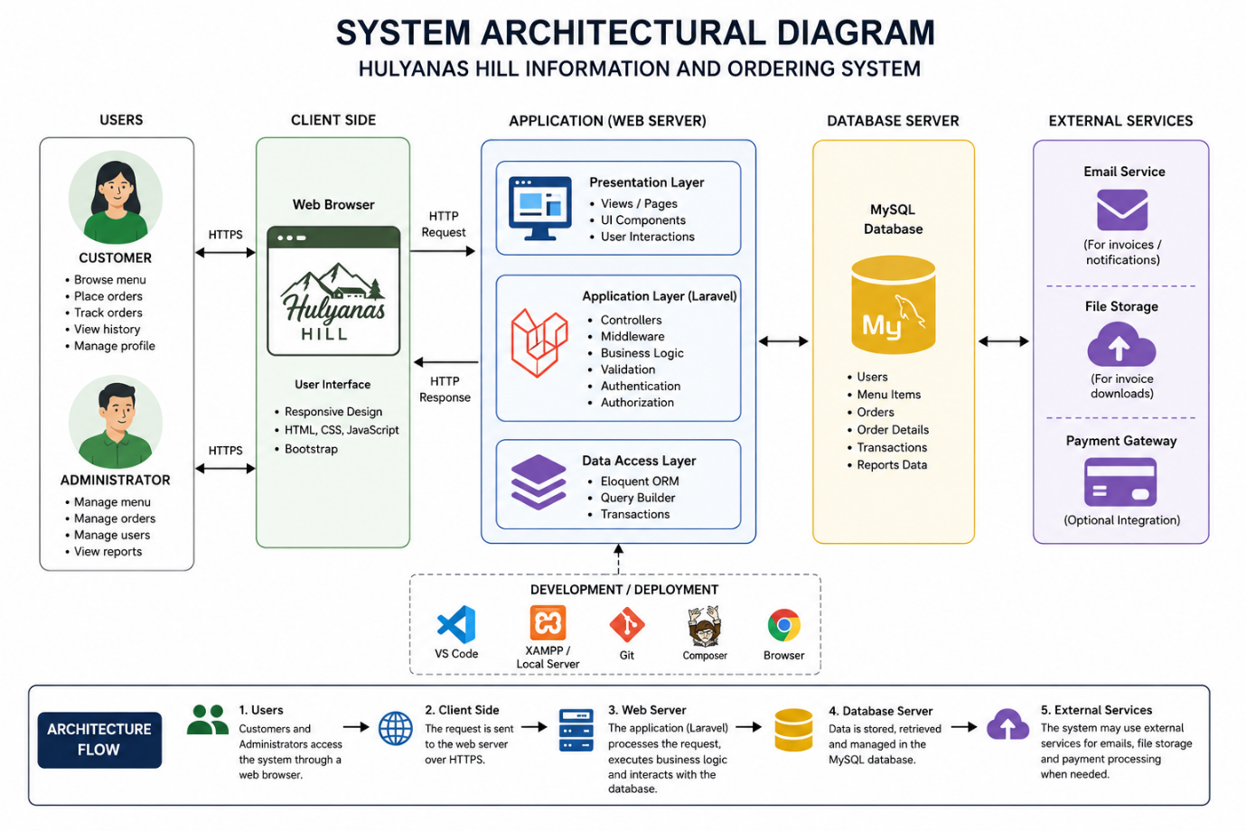

Figure 4: System Architectural Diagram

Interface Design/Screenshots
Main Page
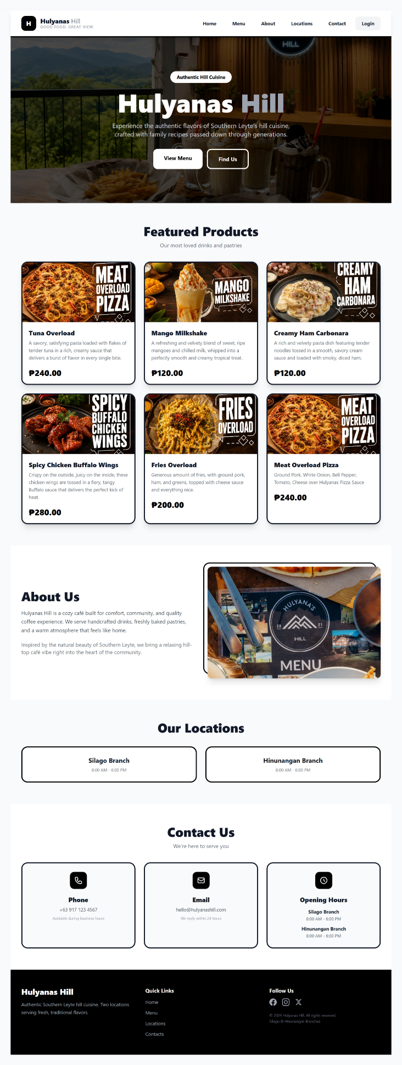

Login and Register Page
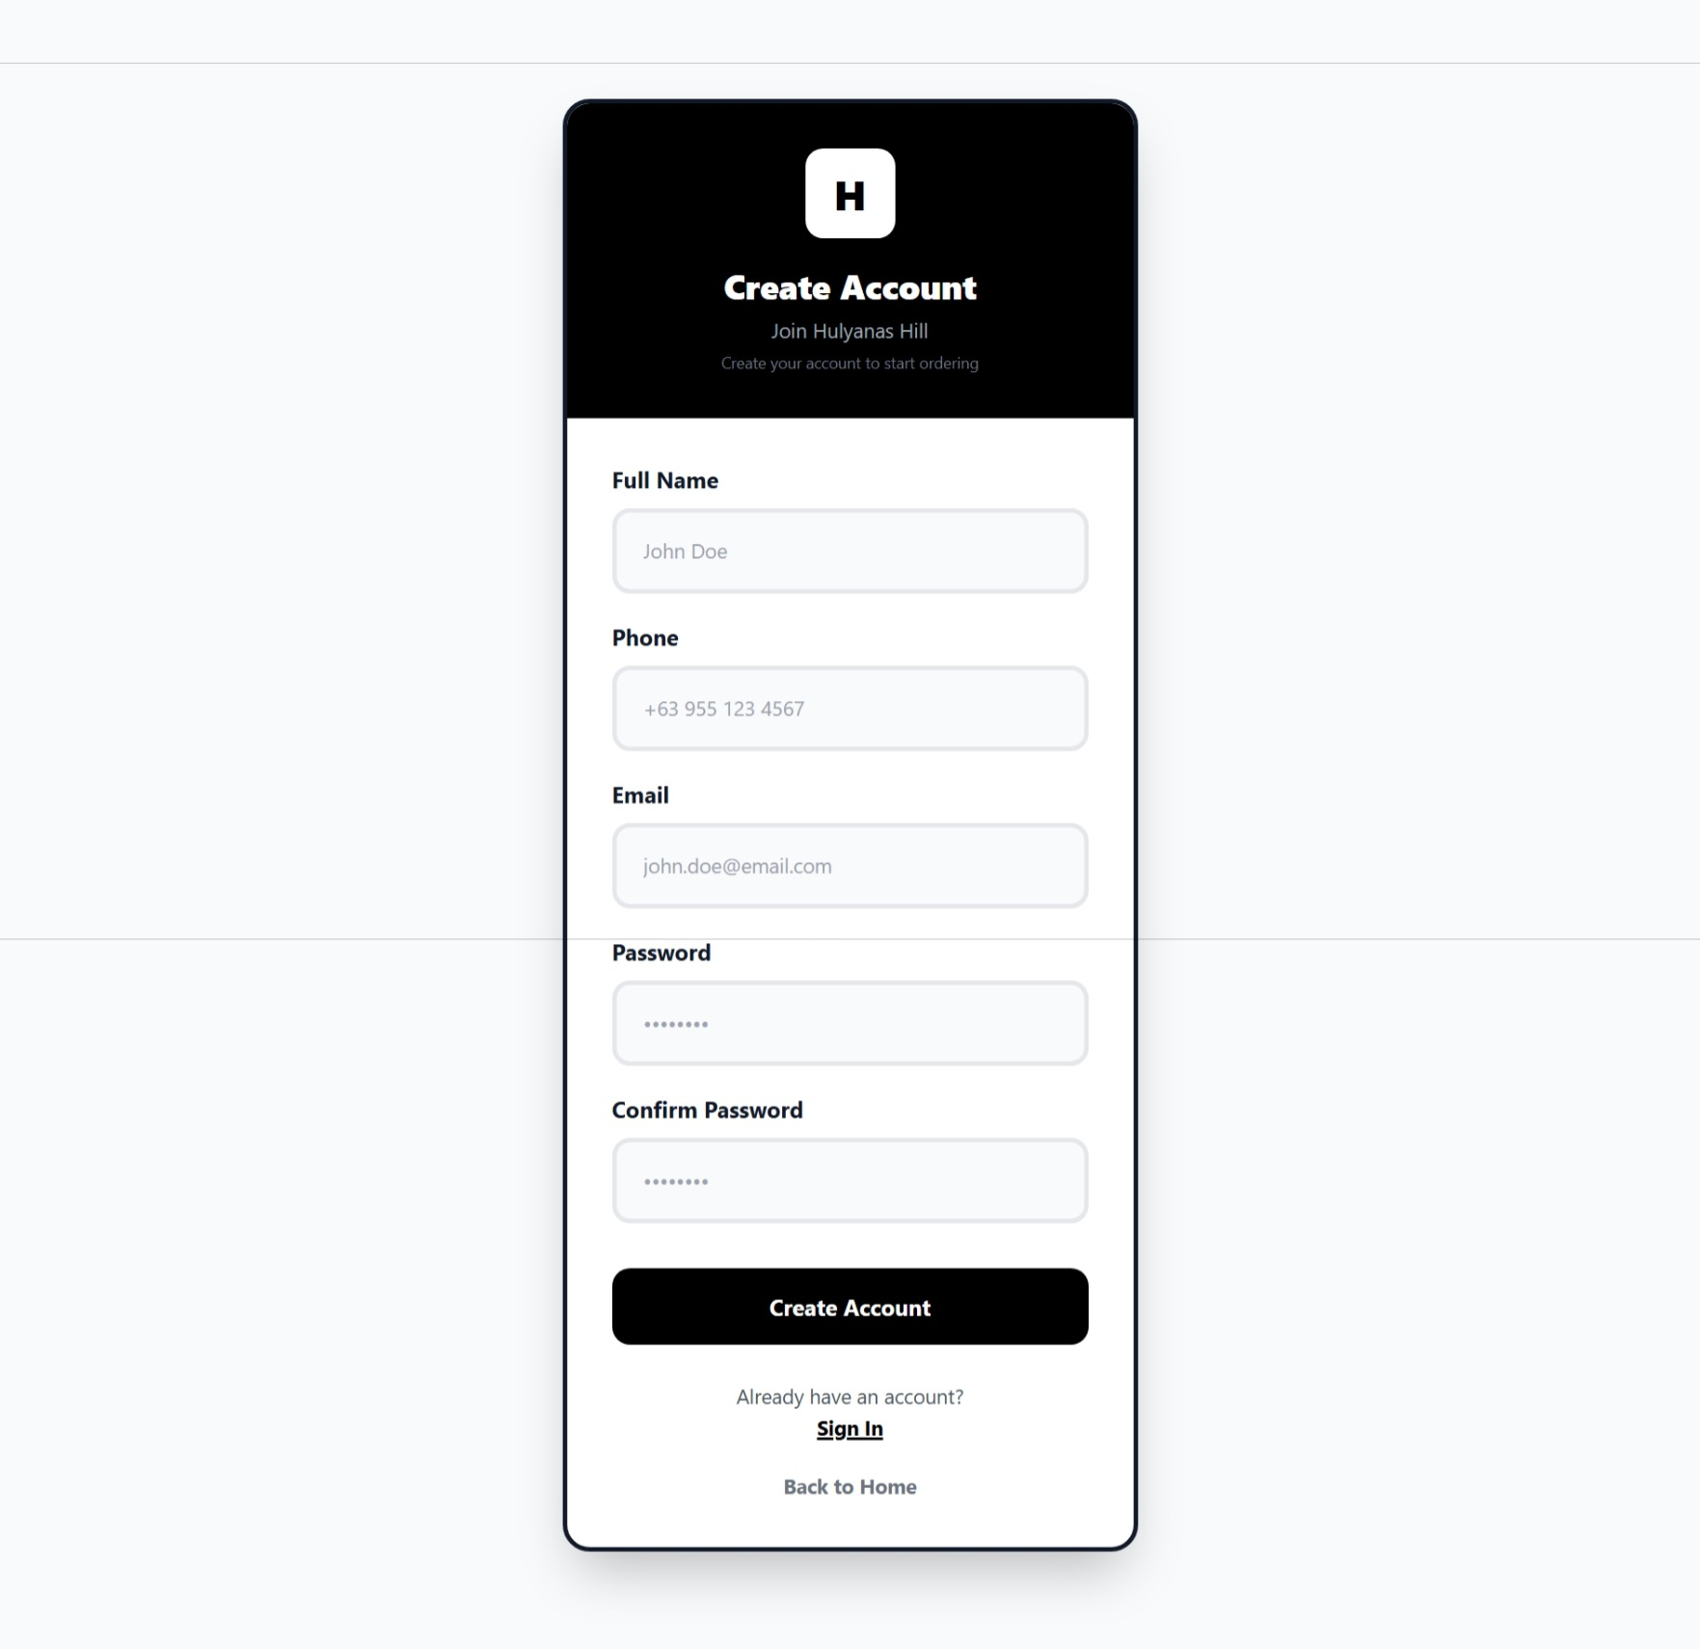
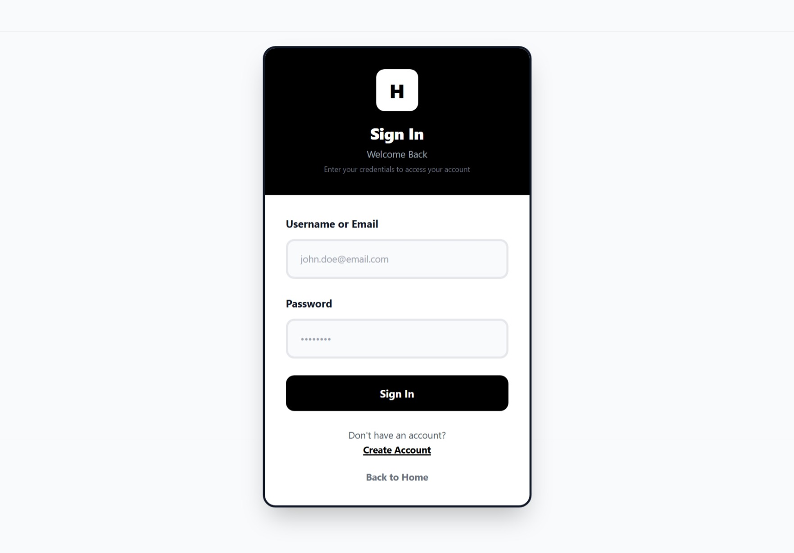
ADMIN PANEL
Admin Dashboard
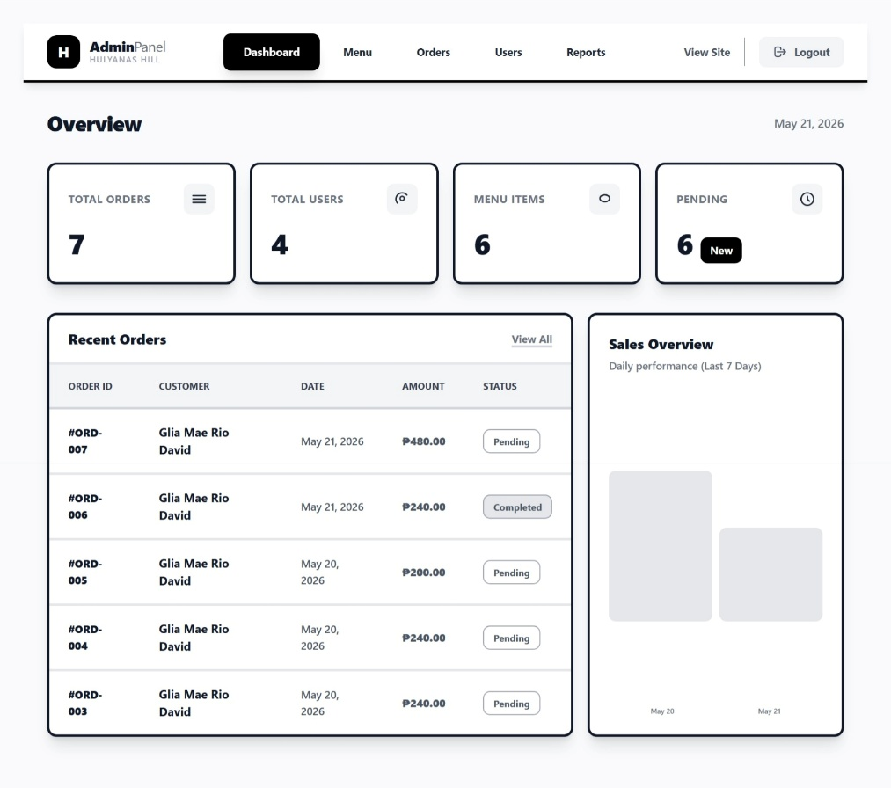
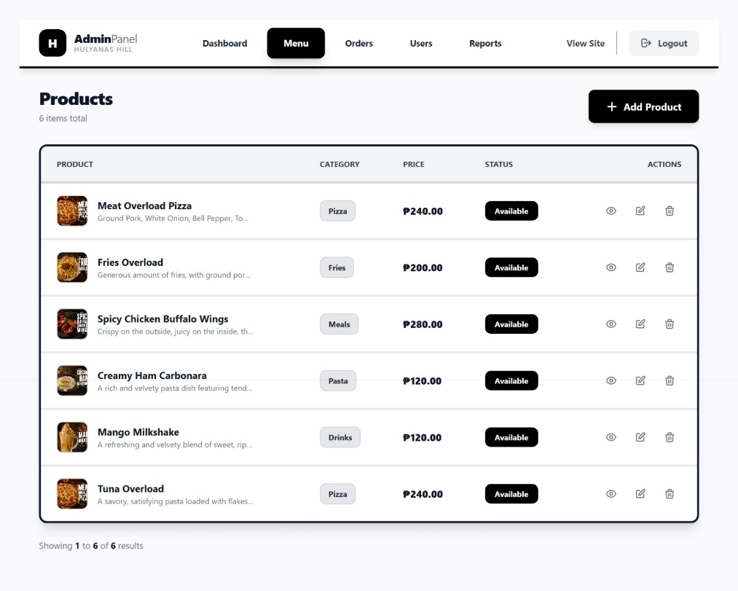

Admin Manage Menu

View Menu Details
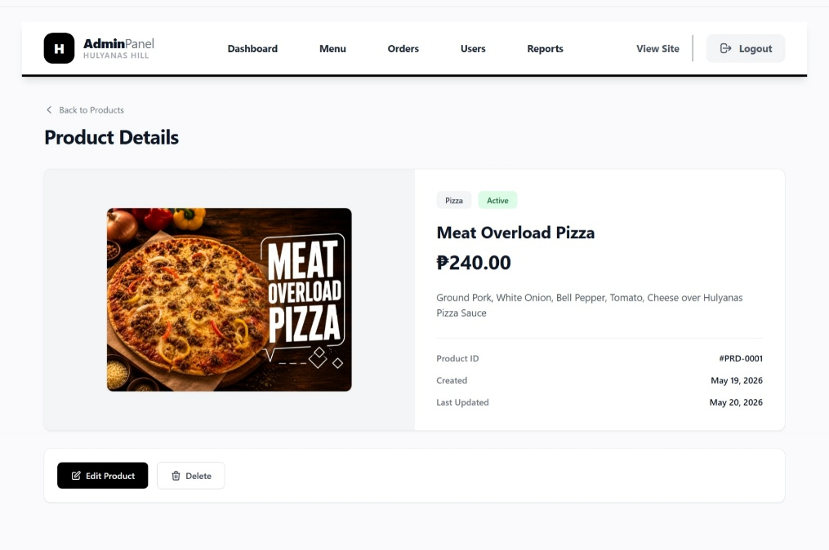
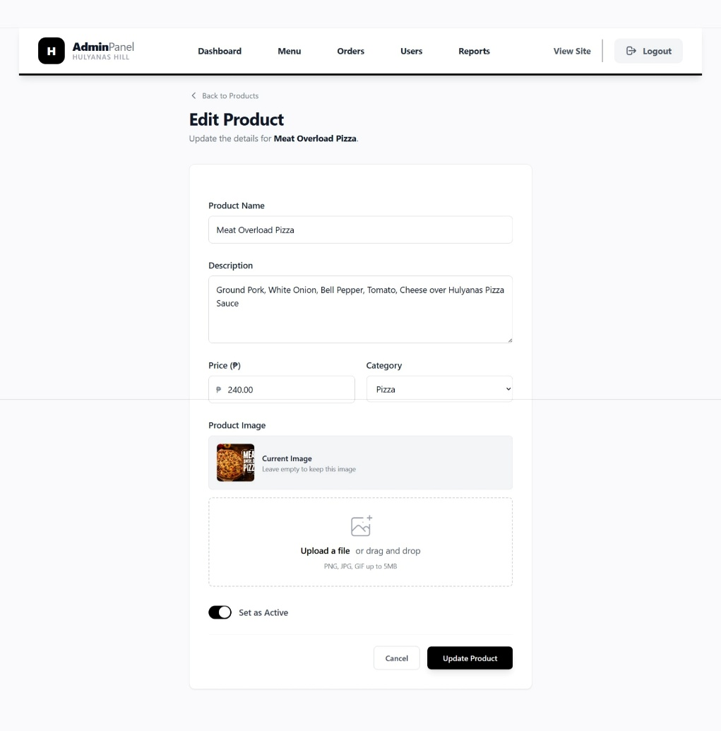

Edit Menu

Manage Orders
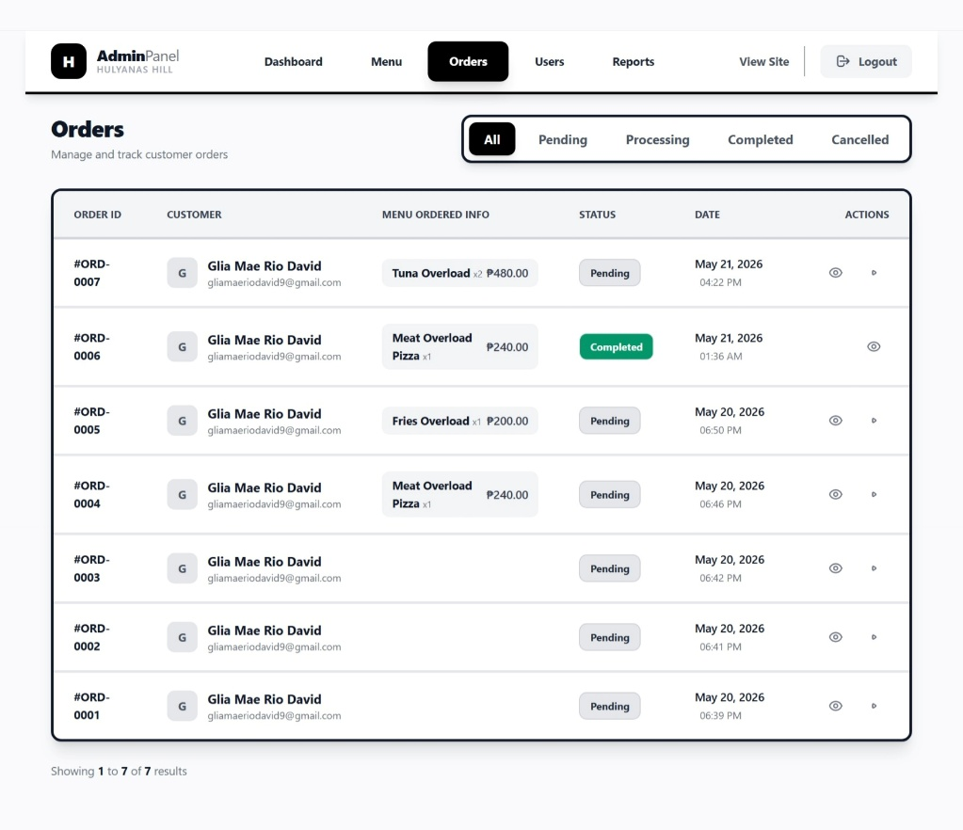

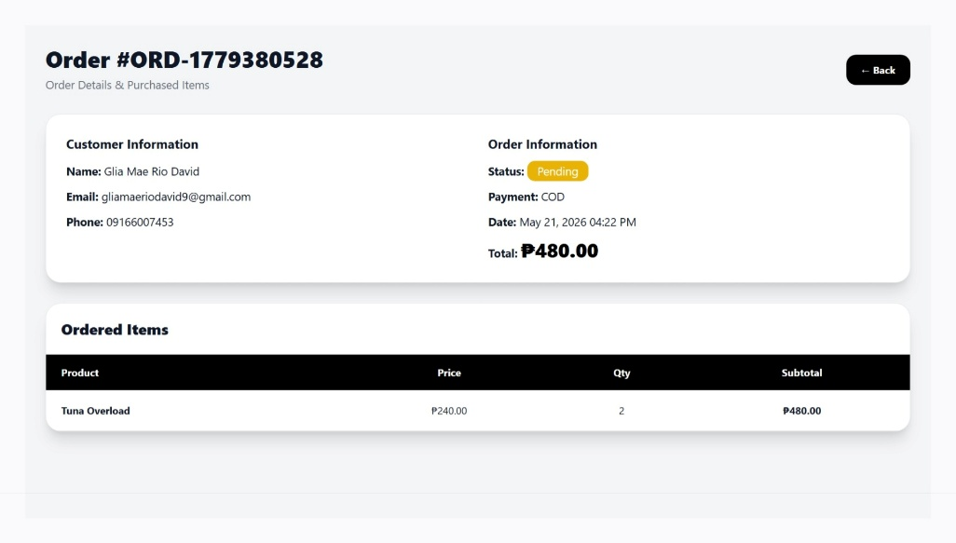
View Order Details

Manage Users
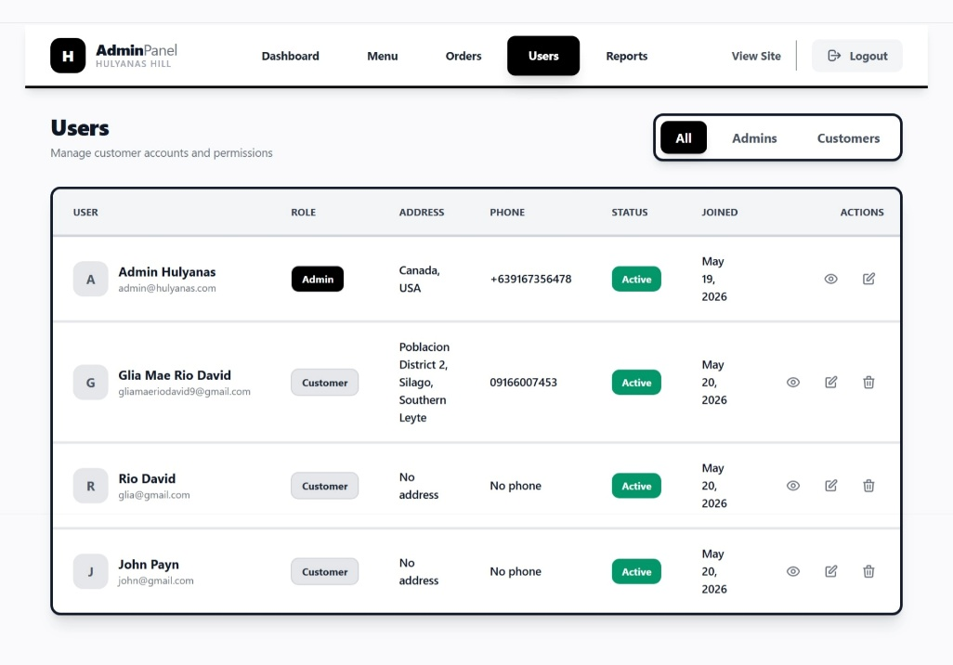

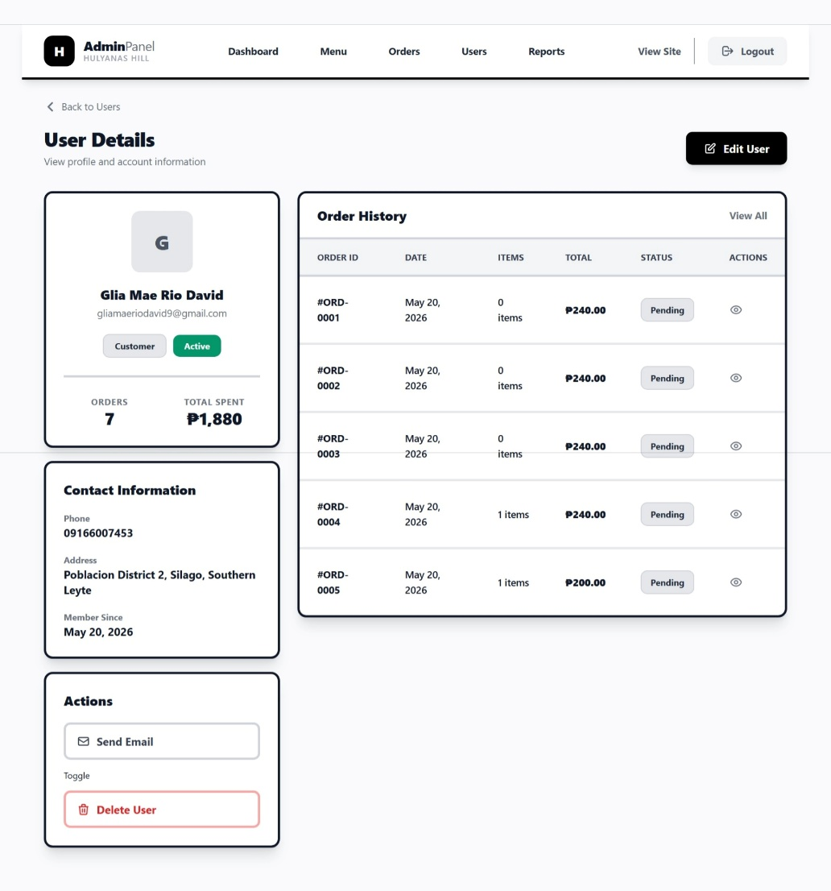
View User Details

Edit User Details
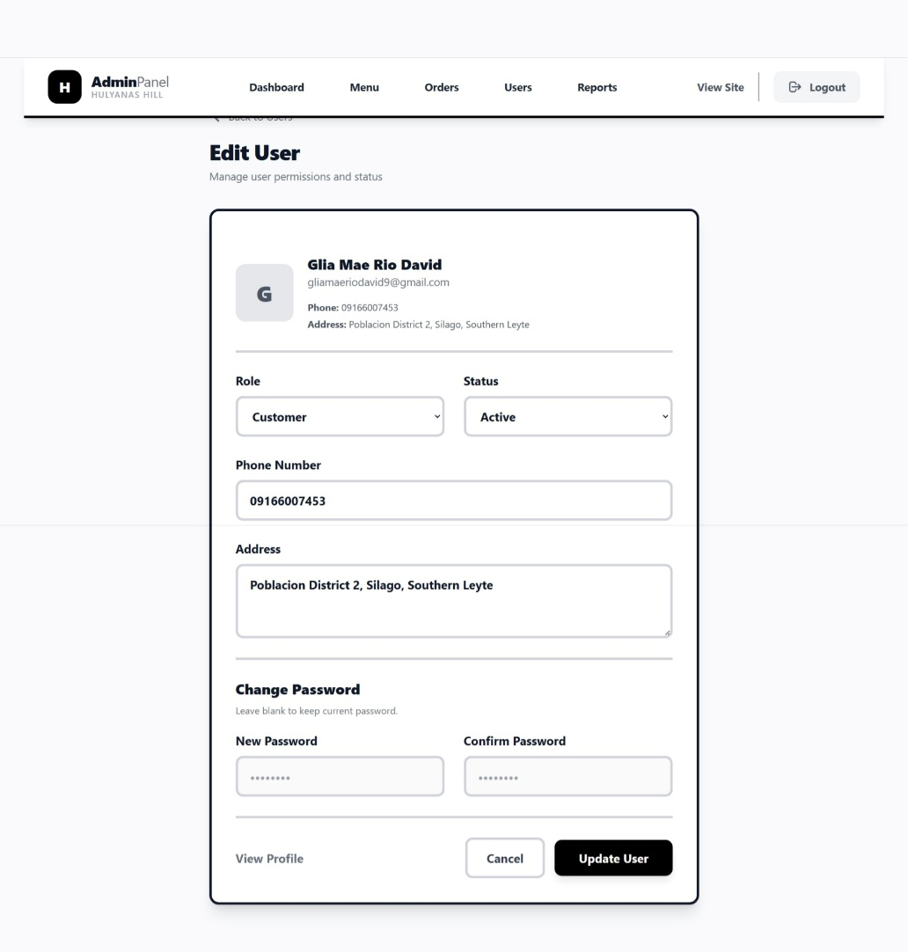
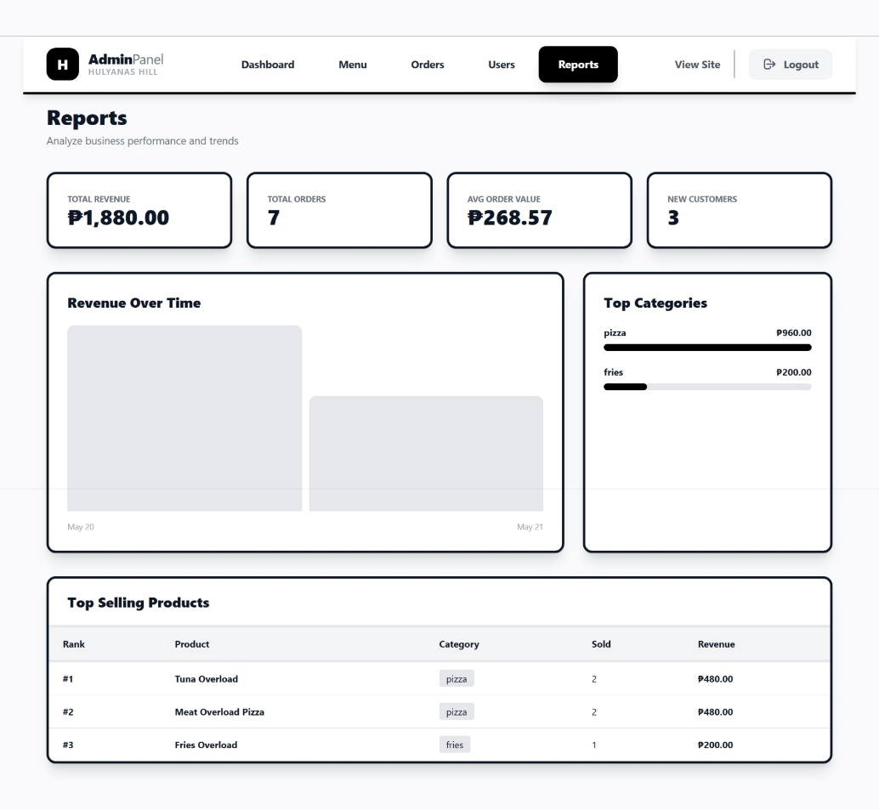

View Reports

USER PANEL
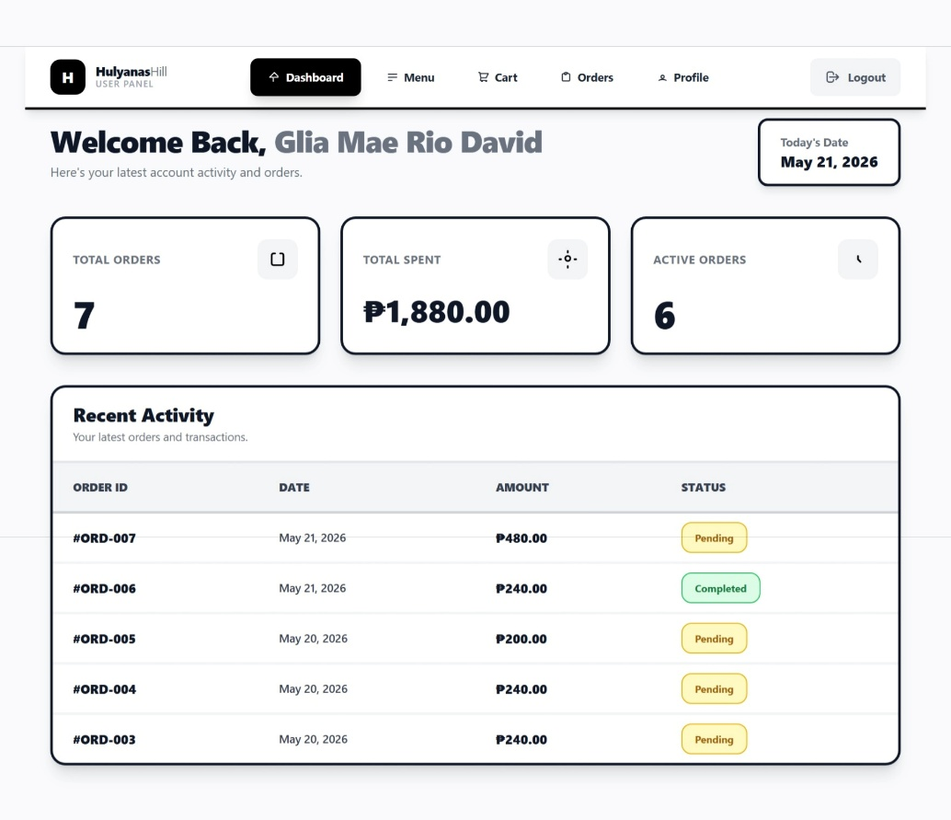
User Dashboard

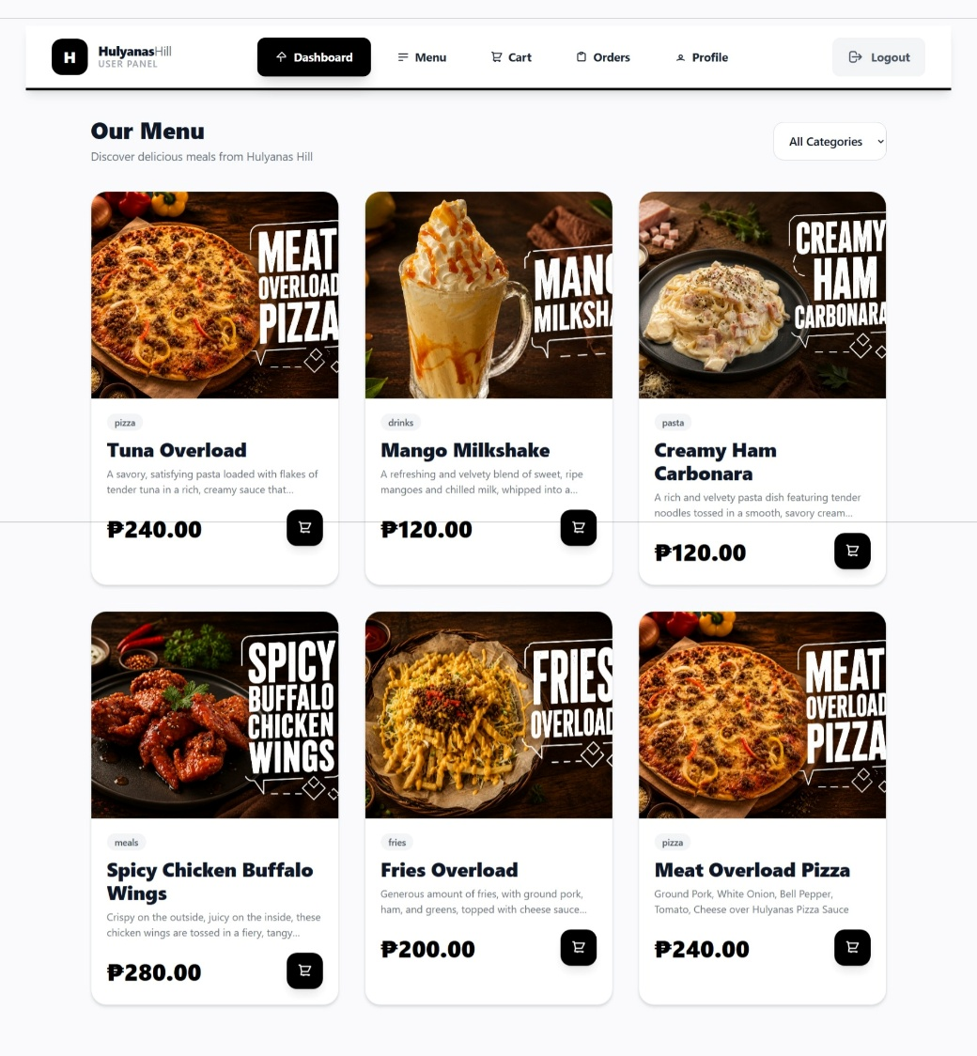
View Menu

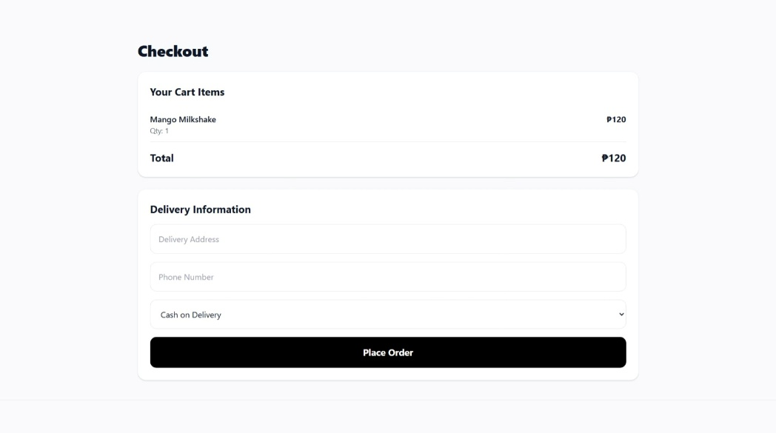
Manage Cart
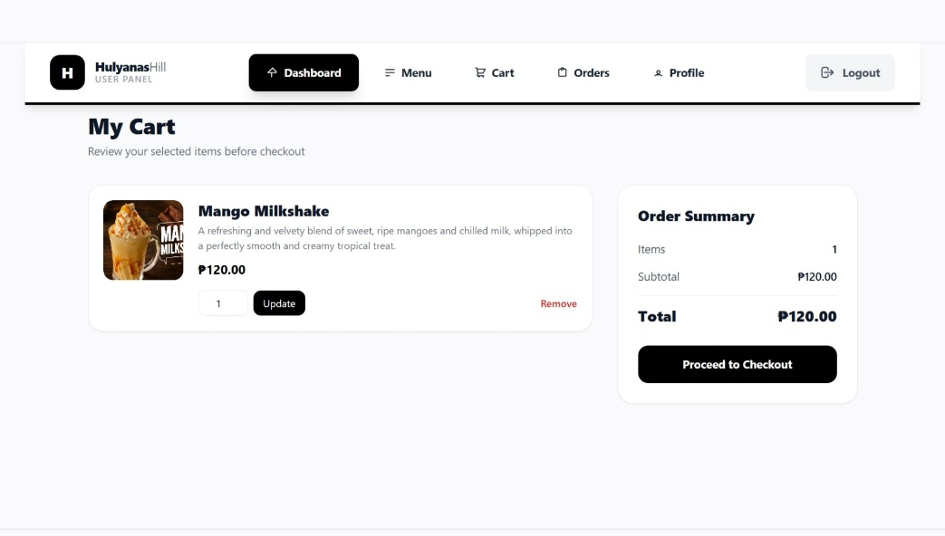

Checkout Orders

View/Track Orders
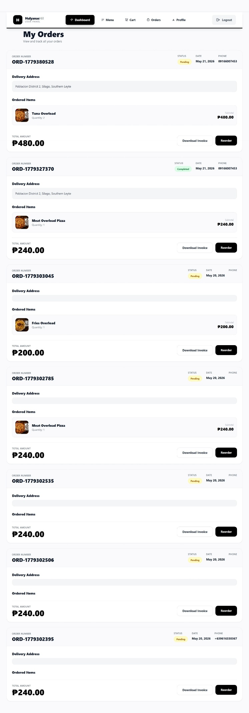

Sample Invoice
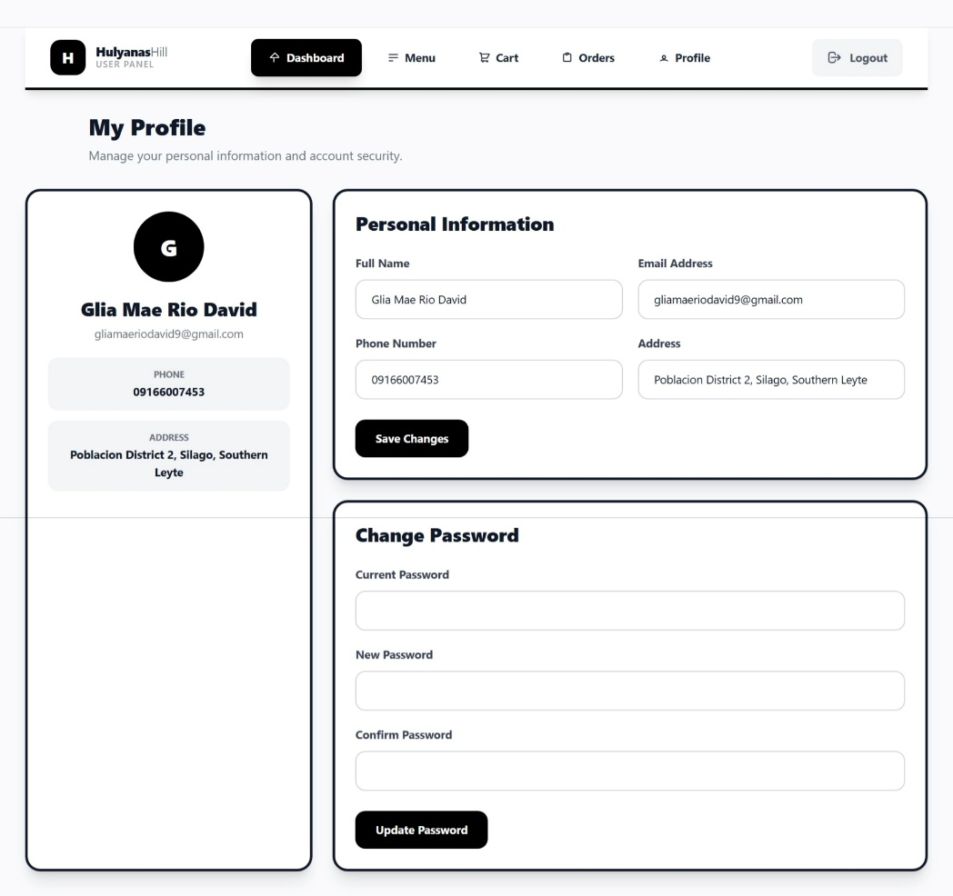
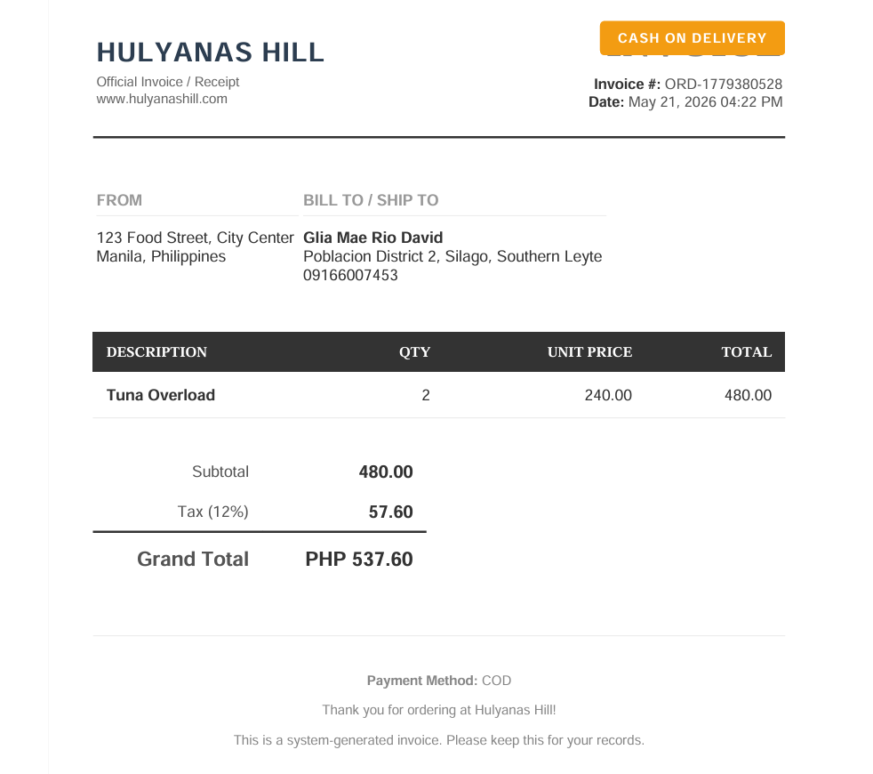

Manage Profile

DATABASE STRUCTURE
Based on the ER diagram, the system follows a standard e-commerce architecture consisting of five (5) core relational tables. These tables manage users, product listings, shopping cart transactions, order processing, and order breakdown details.
1. List of Tables
The database consists of the following main tables:
Table Name | Description
users | Stores system user accounts and profile information
products | Stores all available items for purchase
carts | Temporary storage of selected items before checkout
orders | Stores finalized customer transactions
order_items | Stores a detailed breakdown of each order

2. Table Structures and Field Descriptions
2.1 users Table
The users table stores all registered user information, including authentication credentials, profile data, and account status.
Field Name | Description
id | Primary key, unique identifier for each user
name | Full name of the user
email | Email address used for login and communication
email_verified_at | Timestamp indicating email verification status
password | Encrypted password for secure authentication
remember_token | Token used for persistent login sessions
role | Defines user type (e.g., admin, customer)
is_active | Account status (1 = active, 0 = inactive/suspended)
address | Default delivery or billing address
phone | Contact number of the user
created_at | Date and time when the account was created
updated_at | Date and time of last profile update

2.2 products Table
The products table contains all items available for purchase in the system such as meals, drinks, or other menu items.
Field Name | Description
id | Primary key, unique product identifier
name | Name of the product
description | Detailed information about the product
price | Selling price of the product (DECIMAL 8,2 format)
category | Classification (e.g., meals, pizza, fries, etc.)
image | File path or URL of product image
is_active | Availability status (1 = available, 0 = hidden/unavailable)
created_at | Timestamp when product was added
updated_at | Timestamp of last modification

2.3 carts Table
The carts table temporarily stores products selected by users before they proceed to checkout.
Field Name | Description
id | Primary key, unique cart item ID
user_id | Foreign key referencing users.id
product_id | Foreign key referencing products.id
quantity | Number of units selected by the user
created_at | Timestamp when item was added to cart
updated_at | Timestamp of last update

2.4 orders Table
The orders table records all completed transactions after checkout.
Field Name | Description
id | Primary key, unique order ID
user_id | Foreign key referencing users.id
order_number | Unique tracking/reference code for the order
total_amount | Total cost of the order (DECIMAL 10,2)
status | Current order status (e.g., pending, paid, processing, delivered, cancelled)
payment_method | Mode of payment (COD)
shipping_address | Delivery address for the order
phone | Contact number for delivery coordination
created_at | Timestamp when order was placed
updated_at | Timestamp of last update

2.5 order_items Table
The order_items table stores the detailed breakdown of each order, including the individual products purchased.
Field Name | Description
id | Primary key, unique order item ID
order_id | Foreign key referencing orders.id
product_id | Foreign key referencing products.id
product_name | Snapshot of product name at time of purchase
price | Product price at the time of order
quantity | Number of units purchased
subtotal | Computed value (price × quantity)
created_at | Timestamp when record was created
updated_at | Timestamp of last update

3. Relationships Between Tables
This system follows a relational database structure with one-to-many and many-to-one relationships.
users → carts
- Type: One-to-Many
- Description: A single user can add multiple items to their cart
- Foreign Key: carts.user_id → users.id
users → orders
- Type: One-to-Many
- Description: A single user can place multiple orders over time
- Foreign Key: orders.user_id → users.id
carts → products
- Type: Many-to-One
- Description: Each cart item is linked to a single product
- Foreign Key: carts.product_id → products.id
orders → order_items
- Type: One-to-Many
- Description: One order can contain multiple products/items
- Foreign Key: order_items.order_id → orders.id
products → order_items
- Type: One-to-Many
- Description: A product can appear in multiple order records
- Foreign Key: order_items.product_id → products.id

products → carts
- Type: One-to-Many
- Description: A product can exist in multiple users' carts simultaneously
- Foreign Key: carts.product_id → products.id

IMPLEMENTATION AND TESTING
This section presents a comprehensive discussion of the system implementation process, the detailed testing procedures performed to ensure system reliability, the problems encountered during development, and the solutions implemented to resolve them. The system follows a structured development lifecycle using the Laravel framework and MySQL database.
1. DEVELOPMENT PROCESS
The development of the system was carried out using a systematic and modular approach. The process was divided into several phases to ensure that each component was properly designed, implemented, and integrated.
  - Requirement Analysis Phase
The initial phase focused on identifying and analyzing the system requirements from both user and administrative perspectives. Typical e-commerce workflows such as product browsing, cart management, checkout, and order tracking were studied to understand the system’s functionality. The main system actors identified were the administrator and the customer. Functional requirements, including user authentication, product browsing, cart management, order processing, and order tracking, were defined, along with non-functional requirements such as security, performance, and data integrity to ensure a reliable and efficient system.
  - System Design Phase
After gathering the system requirements, the design phase was conducted to define the system's overall architecture and database structure. An ER diagram was created containing five core tables: users, products, carts, orders, and order_items. Database normalization was applied to reduce redundancy, while primary and foreign keys were used to establish proper relationships between tables. The order details were separated into the order_items table to improve scalability and organization. The system also follows the MVC (Model-View-Controller) architecture, where the Model handles database operations through Eloquent ORM, the View manages the user interface using Blade templates, and the Controller processes requests and business logic.

  - Backend Development Phase
The backend was developed using the Laravel Framework (PHP), which provided routing, ORM support, and built-in authentication features. The system includes modules for user authentication, product management, cart management, and order processing. These modules handle functions such as user registration and login, product CRUD operations, cart item management, and converting cart items into confirmed orders. An order items module was also implemented to store purchased products and preserve product details during transactions.
1.4 Frontend Development Phase
The frontend was developed using Blade templates with Tailwind CSS/Bootstrap for styling. It includes key interfaces such as the product listing page, shopping cart, checkout form, order summary, and admin dashboard. The design focuses on responsive layouts, simple navigation, and clear action buttons to provide a smooth user experience across different devices.
  - Database Integration Phase
The system was integrated with a MySQL database using Laravel migrations to automatically create tables and Eloquent ORM for database interactions. Relationships between tables were properly defined, such as users having many orders and orders containing multiple order items. Seeders were also used to populate the database with initial product data.
  - System Deployment (Local Environment)
The system was deployed in a local development environment for testing using XAMPP for Apache and MySQL services, Laravel Artisan Server for running the application, and phpMyAdmin for database management.

2. TESTING PROCEDURES PERFORMED
To ensure the system meets functional and technical requirements, multiple levels of testing were conducted.
2.1 Unit Testing
Each module was tested individually to ensure correctness, including user authentication, product CRUD operations, cart functions, and order creation. The objective was to verify that each component works properly before system integration.
2.2 Integration Testing
This testing focused on verifying the interaction between system modules. It ensured that adding products to the cart is correctly reflected in the database, the checkout process properly transfers cart data into the orders table, order items are accurately generated from cart items, and user-specific data remains isolated so one user cannot access another user’s cart.
2.3 Functional Testing
This testing validated whether the system meets the required business functions. It confirmed that users can successfully register and log in, products are properly displayed on the interface, cart operations work as expected, orders are correctly created and stored in the database, and administrators can effectively manage product inventory.
2.4 Database Testing
This testing focused on ensuring database integrity and consistency. It verified foreign key constraints, checked data consistency between orders and order_items, validated correct calculation of totals (subtotal × quantity), and ensured that no orphan records exist in the database.
2.5 User Interface Testing
UI testing ensured the usability and responsiveness of the system. It checked layout adaptability across different screen sizes, button functionality such as hover and click actions, form validation messages, smooth navigation between pages, and proper display of error messages for invalid inputs.

3. PROBLEMS ENCOUNTERED
During development, several technical and logical issues were encountered.
3.1 Foreign Key Constraint Errors
Problem: Data insertion failed when referencing a non-existent user_id or product_id.
Cause: Improper validation before inserting cart and order data.
3.2 Null Reference Errors in Views
Problem: Blade templates crashed due to null or undefined variables.
Cause: Missing data passed from controllers to views.
3.3 Incorrect Order Total Computation
Problem: The displayed total amount did not match the actual computed subtotal.
Cause: Inconsistent calculation between frontend and backend logic.
3.4 Cart Synchronization Issues
Problem: Cart items were not consistently updated after login/logout.
Cause: Mix of session-based and database-based cart implementation.
3.5 Routing and View Errors
Problem: Pages returned errors such as: Route not defined / View not found
Cause: Incomplete route declarations and incorrect controller mappings.

4. SOLUTIONS APPLIED
Each problem was resolved through structured debugging and system improvement.
4.1 Foreign Key Validation Fix
Solution: The issue was resolved by adding validation rules in the controllers to ensure that both user and product records exist before insertion. Cascading relationships were also implemented in the database migrations using onDelete('cascade') to maintain data integrity.
4.2 Blade Null Safety Handling
Solution: The issue was resolved by using Laravel helper functions such as optional(), @isset, and @forelse to handle null values safely in the views. Default fallback values were also added for empty datasets to prevent errors and improve stability.
4.3 Order Calculation Correction
Solution: The issue was resolved by centralizing all calculations in the backend to ensure accuracy and consistency. The system enforces the formula where subtotal is computed as price × quantity, and total amount is calculated as the sum of all subtotals. This approach also prevents frontend manipulation of computed values, improving data integrity and security.
4.4 Cart System Standardization
Solution: The issue was resolved by removing session-based cart inconsistencies and fully migrating the cart system to a database-based structure. The cart was then directly linked to the authenticated user ID to ensure proper data consistency and reliable cart management.
4.5 Routing and View Correction
Solution: The issue was resolved by defining missing routes in web.php, standardizing controller naming conventions, and ensuring that all controllers properly return valid Blade views.

CONCLUSION
The Hulyanas Hill Information and Ordering System was successfully developed as a fully functional e-commerce platform that efficiently manages users, products, carts, and order transactions. The project achieved its main goal of replacing manual ordering processes with a structured digital system that ensures secure user authentication, effective product management, smooth cart operations, and reliable order processing. It also implemented a well-designed relational database using MySQL, along with a responsive and user-friendly interface for both customers and administrators.
The system provides clear benefits to its users and administrators. Customers enjoy a more convenient and faster ordering experience with accurate order tracking and easy cart management, while administrators benefit from centralized control over products, orders, and customer data, reducing manual workload and improving operational efficiency. Overall, the system enhances accuracy, improves data organization, and supports scalable improvements for future features such as payment integrations and delivery tracking.
Throughout the development process, valuable knowledge and skills were gained in Laravel development, MVC architecture, database management, and secure authentication systems. The project also strengthened problem-solving abilities, especially in debugging database errors, handling system validations, and maintaining data consistency. In addition, it provided practical insight into real-world e-commerce workflows and the importance of proper system design, testing, and modular development.
In conclusion, the project successfully delivered a stable and efficient ordering system while serving as a significant learning experience in full-stack web development. It provides a strong foundation for future enhancements and real-world application use.

RECOMMENDATIONS
This section presents suggested improvements, additional features, and enhancement ideas that can further develop and upgrade the current system in future versions.
1. Future Improvements
To enhance the overall performance, scalability, and usability of the system, the following improvements are recommended:
- Performance Optimization – Use caching, query optimization (Eloquent eager loading), and pagination to improve speed and efficiency.
- Security Enhancements – Implement 2FA, rate limiting, strong validation, and data encryption to protect the system from attacks.
- Database Optimization – Improve structure with normalization, indexing (e.g., product_name, user_id), and soft deletes for better data handling.
- System Scalability – Prepare for cloud deployment, apply load balancing, and consider API-based architecture for future expansion.
2. Additional Features
To improve user experience and system functionality, the following features can be added:
- Payment Gateway Integration – Support GCash, PayMaya, PayPal, and card payments for seamless online transactions.
- Order Tracking System – Provide real-time order status updates (Pending, Processing, Out for Delivery, Delivered).
3. System Enhancement Ideas
The system can also be improved through advanced architectural and UX enhancements:
- Mobile App Development – Create a companion app using Flutter or React Native to improve mobile accessibility.
- API Development – Convert the system into a RESTful API for integration with mobile apps, third-party services, and external marketplaces.
- AI-Based Recommendations – Implement AI to suggest products based on user behavior and show “Frequently Bought Together” items.
- Inventory Management System – Add stock tracking, automatic availability updates, and low-stock notifications for admins.

